Karthikeya srinivasulu (192312112)
Exp.N.3: Spectrum Analysis of Sub-1 GHz, Mid-band & mmWave by Plotting Propagation
Loss. Date
AIM:
To analyze the propagation loss characteristics of different frequency bands (Sub-1 GHz, Mid-
band, and mmWave) in wireless communication systems and compare their performance over
varying distances using MATLAB.
Objective :
1. To compute the Propagation Loss (dB) for Sub-1 GHz, Mid-band, and mmWave
frequency ranges using standard path loss models.
2. To evaluate the impact of different Operating Frequencies (GHz) on signal attenuation
and coverage performance.
3. To analyze how Communication Distance (km) affects propagation loss across
different spectrum bands.
Procedure
1. Define frequency bands: Sub-1 GHz (0.9 GHz), Mid-band (3.5 GHz), and mmWave (28
GHz).
2. Set communication distance range (e.g., 0.1 km to 5 km).
3. Use Free Space Path Loss (FSPL) formula to compute propagation loss:

PL(dB)=20log⁡10(d)+20log⁡10(f)+32.44

4. Calculate propagation loss for each frequency band over varying distances.
5. Plot distance vs propagation loss curves for comparison.
6. Analyze how higher frequencies experience higher attenuation.
7. Compare coverage efficiency of each spectrum band.
8. Display results using MATLAB plots.
Objective 1: Matlab Code and Output:
clc; clear; close all;
d = 0.1:0.1:5; % Distance (km)
f = [900 3500 28000]; % Frequency (MHz)
PL1 = 32.44 + 20*log10(f(1)) + 20*log10(d);
PL2 = 32.44 + 20*log10(f(2)) + 20*log10(d);
PL3 = 32.44 + 20*log10(f(3)) + 20*log10(d);
figure
% -------- Graph 1 --------
subplot(2,1,1)

plot(d,PL1,'b','LineWidth',2); hold on
plot(d,PL2,'r','LineWidth',2)
plot(d,PL3,'k','LineWidth',2)
title('Propagation Loss vs Distance')
xlabel('Distance (km)')
ylabel('Loss (dB)')
grid on
% -------- Graph 2 (NO legend used to avoid error) --------
subplot(2,1,2)
Freq = [900 3500 28000];
Loss = [PL1(10) PL2(10) PL3(10)];
plot(Freq,Loss,'-o','LineWidth',2)
title('Propagation Loss vs Frequency')
xlabel('Frequency (MHz)')
ylabel('Loss (dB)')
grid on
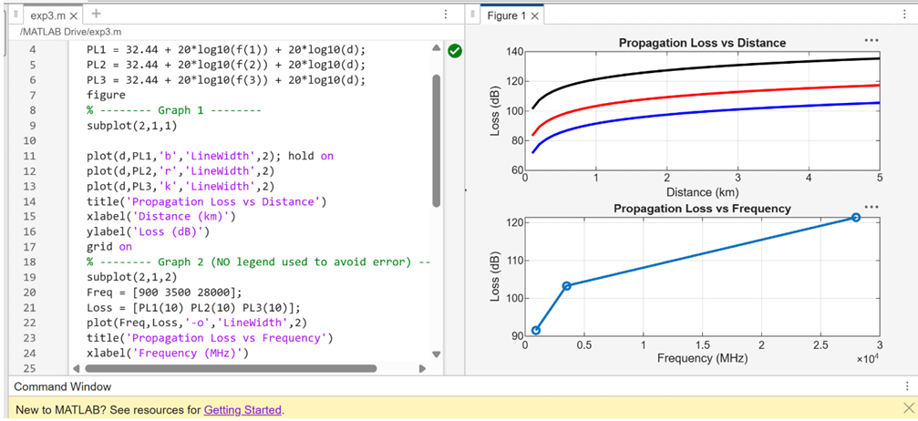
FIG.1.
The graph shows that propagation loss increases with both communication distance and operating
frequency in wireless systems.
mmWave experiences the highest loss, while Sub-1 GHz provides better coverage and lower
attenuation.
Objective 2: Matlab Code and Output:
clc; clear; close all;
d = 2; % fixed distance (km)

f = [900 3500 28000]; % MHz
PL = 32.44 + 20*log10(f) + 20*log10(d);
figure
% -------- Graph 1: Frequency vs Loss --------
subplot(2,1,1)
plot(f,PL,'-o','LineWidth',2)
title('Propagation Loss vs Operating Frequency')
xlabel('Frequency (MHz)')
ylabel('Propagation Loss (dB)')
grid on
% -------- Graph 2: Band Comparison --------
subplot(2,1,2)
bar(PL)
title('Comparison of Propagation Loss Across Bands')
xlabel('Frequency Bands (Index: 1=Sub-1GHz, 2=Mid-band, 3=mmWave)')
ylabel('Propagation Loss (dB)')
xticklabels({'Sub-1GHz','Mid-band','mmWave'})
grid on
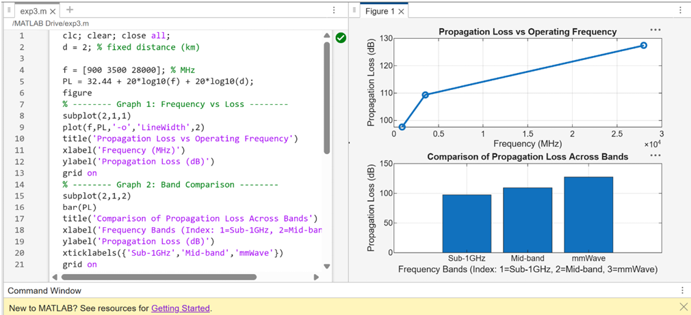
FIG.2.
The graph shows that propagation loss increases as operating frequency increases.
mmWave experiences the highest attenuation, while Sub-1 GHz has the lowest loss.

The bar chart clearly compares the loss across different frequency bands at the same distance.
It highlights that higher frequency bands require stronger signal enhancement techniques for
reliable communication.
Objective 3: Matlab Code and Output:
clc; clear; close all;
% Frequency bands (MHz)
f = [900 3500 28000];
% Distance (km)
d = 2;
% Propagation Loss (FSPL)
PL = 32.44 + 20*log10(f) + 20*log10(d);
figure
% -------- Graph 1: Simple Line Plot (SAFE) --------
subplot(2,1,1)
plot(f, PL, '-o', 'LineWidth', 2)
title('Propagation Loss vs Operating Frequency')
xlabel('Frequency (MHz)')
ylabel('Propagation Loss (dB)')
grid on
% -------- Graph 2: Safe Comparison Plot --------
subplot(2,1,2)
plot(1:3, PL, '-s', 'LineWidth', 2)
title('Band-wise Propagation Loss Comparison')
xlabel('Band Index (1=Sub1GHz, 2=Mid-band, 3=mmWave)')
ylabel('Propagation Loss (dB)')
grid on

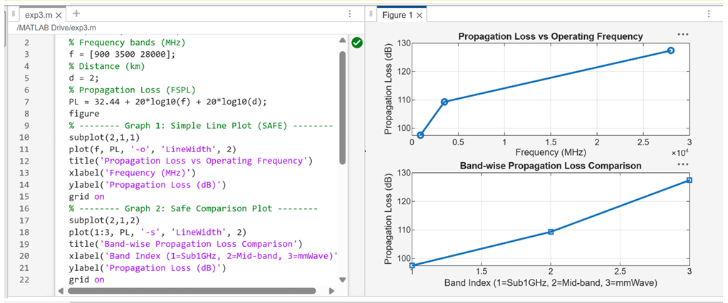
FIG.3.

Propagation loss increases with frequency, showing that mmWave suffers highest attenuation.
The band-wise plot clearly compares Sub-1 GHz, Mid-band, and mmWave performance.
Result:
1. The propagation loss was successfully computed for Sub-1 GHz, Mid-band, and
mmWave frequency bands using the Free Space Path Loss (FSPL) model.
2. It was observed that propagation loss increases with increase in operating frequency, with
mmWave showing the highest attenuation and Sub-1 GHz showing the lowest loss.
3. The comparative analysis of spectrum bands clearly demonstrates that lower frequency
bands are more suitable for long-range communication, while higher frequency bands require advanced techniques like beamforming for efficient performance.

